Joseph Ayo

1/12/25

CSD 340

Deliverables

1. Visit the World Wide Web Consortium (W3C) website and validate the markup you wrote using their HTML validator. Take a screenshot of the validators results (there should be one or more errors)  
   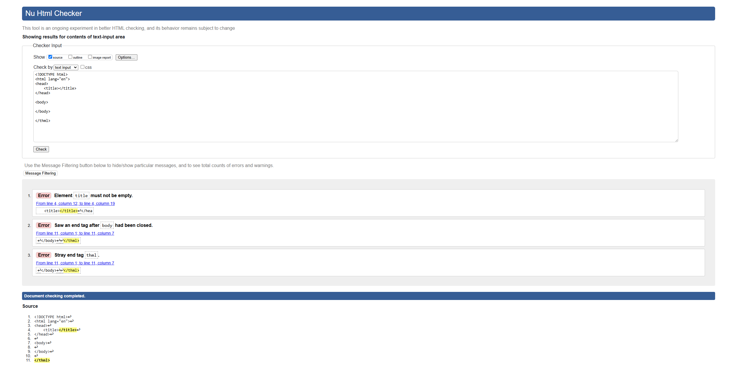
2. Take a screenshot of the updated results (this time, there should be 0 errors)

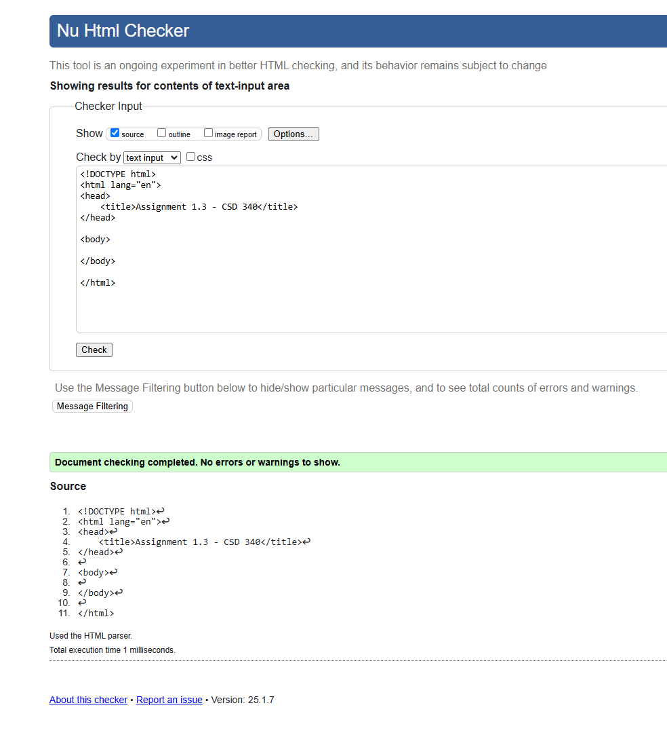

* 1. Add a single h1 element underneath the body element with the following text: “Assignment 1.3 – Building a Web Page Exercise, Part 1”
  2. Add a single sentence under the h1 element that provides info on where you are located and the weather for that location today. You'll need to look up how to type in the degree symbol, either in html or the keyboard.
  3. Update the document's title to “CSD 340 Web Development with HTML and CSS’

Take a screenshot of the updated results (this time, there should be 0 errors)

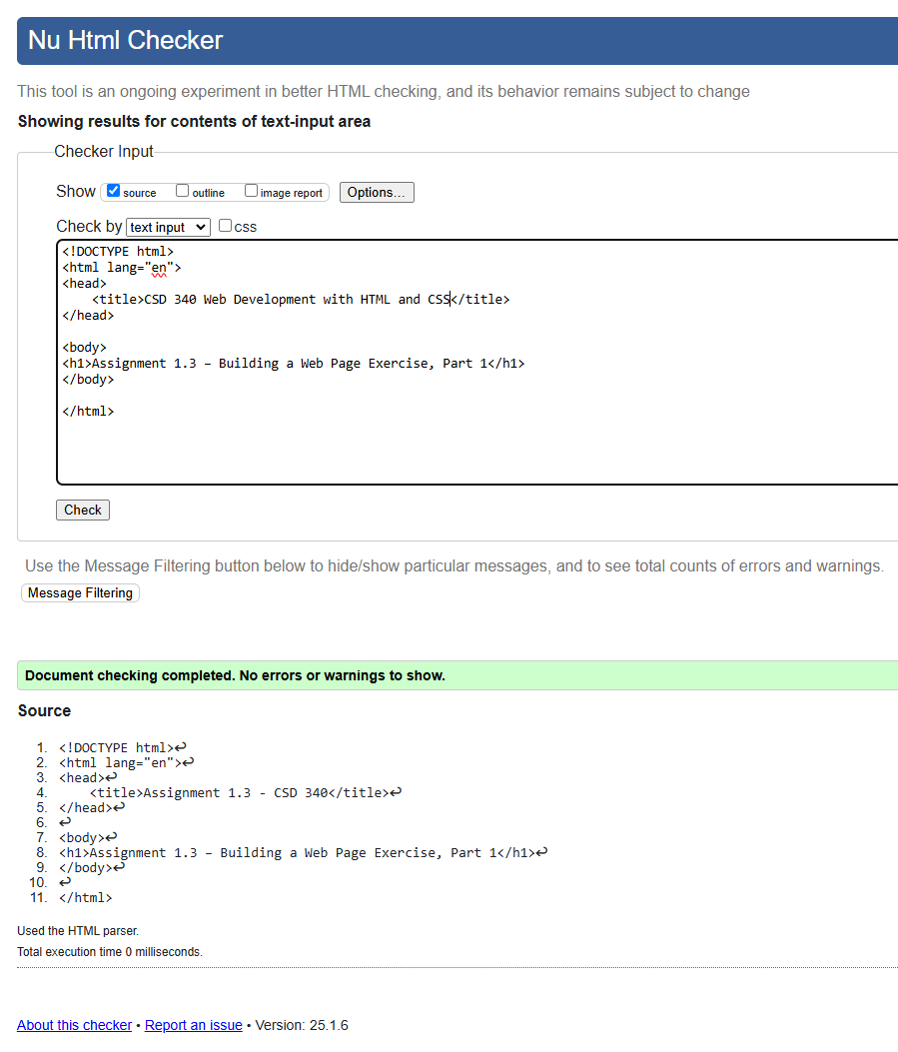

1. Open the file in your computer's default browser and take a screenshot of the web page

